10 Church Street

HSNA Report
November 19, 2019

Harvard Square Neighborhood Association in collaboration with interested individuals from various neighborhoods and fields, including architects, architectural historians, attorneys, engineers and others presents the following report. This is a modified and updated version of the report we forwarded to the CHC and property owner in 2018.
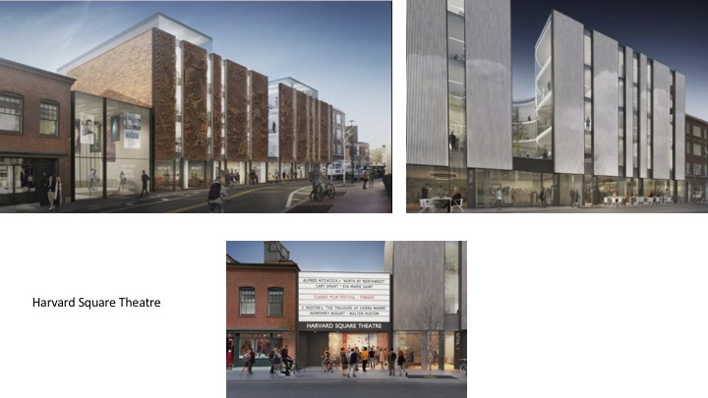

General Overview: There are a number of elements of this design that are positive, including its inclusion of two below ground cinemas, its inclusion of first floor stores, its bold atrium plan that is open to the public visually, the positive impact of its bold creative design will have on Church Street, Palmer Street and Harvard Square more generally. We realize that there are always tradeoffs, and while some would love the public to actually enter the atrium garden, that would clearly not be possible if the proposed stores remain part of the plan, and the latter are key to adding vibrancy to Church Street and Harvard Square more generally. We are pleased with the excellence of many of the design ideas, the quality of the project, and the uniqueness of the plan. It will clearly become a “statement” structure for Cambridge, and elsewhere for years to come. That said there remain important design considerations that we hope will be addressed.

Design Questions and Proposed Improvements:
General comments:
- Scale (story heights): It is not unusual for a developer's quest to maximize rentable area to collide with the public's desire to limit building height. One typical consequence of this is that floor-to-floor heights are squeezed. The DR building at 48 Brattle handles this with subtlety, offering a welcoming high ceiling in the lobby and compressed ceiling heights elsewhere. It's hard to tell from the Church Street renderings what height is intended for the cinema's ground floor tenants, but they look pretty minimal, compared to the more generous retail proportions elsewhere in the Square. It is important to clarify this and address specifically the retail ceiling heights we want.
• Facade design: While we appreciate the verticality of the proposed façade (which
echoes the predominantly vertical proportions of many other H.S. buildings, and the contemporary expression of the floating planes that separate glass areas), the balance of solid to void in the facade seems slightly perverse. The courtyard areas appear to be 100% glass, while the street facades where there is actually more light and view, are predominantly opaque. The need to relieve these large blank planes seems to be a major driver for the LED lighting. We are interested in the reasoning behind the initial decision to restrict window areas as the designers have, and whether other options were studied.
Comparative design elements. The plan first presented (on the left) is preferable in a number of ways to
the current one, most importantly, the following:
- Needed height set back: In the first design the top level is set back (and in glass) so that it remains visually the same height as the adjacent building (on the right). In the new plan (shown above on the right) the massing and height are too much for this narrow street and setting.
- The entry to the cinema (and building interior?) in the first design (left) is far more elegant, contemporary, and creative than the one in the new design (bottom). We far prefer the original although cinema signage will need to be resolved.
- The atrium will include various plantings, most of which will be visible to businesses on the upper stories. It is not clear what will be seen from below, particularly since, with the roof of the first floor providing a hard surface there will be little space for tree roots and the like. We would like the designers to consider adding (narrow?) sections of a living wall in the atrium along the vertical dividers between the windows so that those viewing the atrium from Church Street will be able to also enjoy some of the greenery. This also could be a nice addition for the office residents inside.
- The façade color and texture in the original rendering with its textured, darker terracotta color and surface (left) has both a contemporary look and fit with the façade materials of structures in the adjacent areas. There is concern that the flat and shiny white ceramic of the new proposed façade not only will not age well (the flat surfaces picking up dirt and possibly visually striping) but also that it will be too jarring a surface for this space and context. Some concern also has been raised that the new design is too severe (in part due to this.
- The moving LED light mural. We like the look and texture of the terracotta cladding. We appreciate the public display of the light panel last spring. This feature more generally, however, receives at once positive and negative responses. Either way, there is a strong desire that the architects decrease the scale of this feature by narrowing the width of the moving screen so that it would not be able to be seen above the roof of the Unitarian Church.
- Negative views: We are concerned that this is too much for this small street and won’t be visible because there is no clear “viewer” vantage. Some of us have questioned energy expenditure. Some of us argue that this element may be too much for this site. Others ask about what happens when this element is broken or when the technology changes. Still others emphasize especially the precedent it would set for other less well-designed lighting installations in areas around the city that have no Historical Commission oversight, zoning or other limits. Some, who have been involved in trying to “tame” lighting in the city are worried about light “pollution” and so wary of the potential for unnecessary and/or excessively bright displays, given the capacity of the LEDs, as described in the proposal, and past practices by multiple developers in Cambridge, that we would prefer no display at all. If there is to be a display, it must be physically impossible for the lights to be brighter than what they say they intend. How does one determine brightness (what is just right for some, may be too bright for other? As one recent contributor to this report, an architect notes “I share the skepticism about the LED signage for all the reasons stated, perhaps most of all the issue of obsolescence. The building will be here for many decades after the LED technology has been supplanted by something else. Aging gracefully is an important architectural virtue. Bottom line, a façade of lights should not be included in this plan.

  - Mid-range issues: we are concerned that there will not be any guidelines on content so it could become advertising and ask for strict conformity with CHC and other guidelines. It is important to know which department will oversee content, light-intensity maximums, hours, etc.? We are concerned that to date the city (BZA, Planning Board, Cambridge Historical Commission) have no set guidelines for light walls such as this and that this needs to be done right because it is possible (likely) that other similar and less well throughout plans will follow in the city. At the same time, some of us wouldn't mind a design band if it were the lower portion of the wall along the street and NOT on the upper portion of the wall, which can be seen from a distance. A horizontal band of texture and subtle design would also remedy the severe, vertical facade with a banded detail.
  - Positive views: it is dynamic, bold, and the programmability means not only that it could become a form of public art (we like the possibility of showcasing the work of children and others); we like that the time it will be on can be limited (though some would like it on until 10PM to lighten up the street); and that it can be turned off for events like church services across the street; we like that its design can be changed out so that it will not become boring over time; we like that it can be programmed so that the intensity of the light can be adjusted.

In the end we are largely excited about key features of this plan (but propose key changes) and hope you will find this report helpful as you go forward.

Suzanne Preston Blier
President, Harvard Square Neighborhood Association

